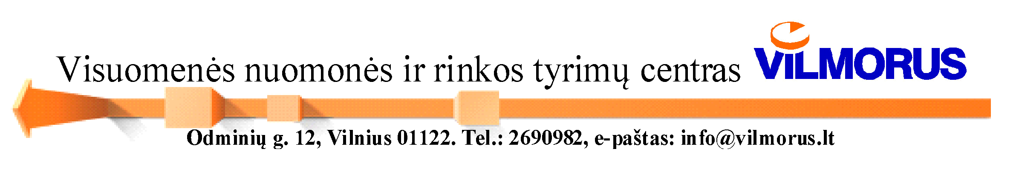

LITHUANIAN CORRUPTION MAP 2025

In October 2025, the Public Opinion and Market Research Center "Vilmorus" conducted a study "Lithuanian Corruption Map 2025", commissioned by the Special Investigation Service of the Republic of Lithuania (SIS).
Two target groups were surveyed: Lithuanian residents and civil servants. A total of 2001 Lithuanian residents and 500 civil servants were interviewed.
The aim of the study is to assess the corruption situation in Lithuania and compare it with the results of previous years. The objectives of the study: to assess the target groups' attitudes towards corruption, the prevalence of corruption in various institutions, to determine the respondents' corruption experience, to assess the anti-corruption potential, and the openness of decision-making in Lithuania. The questionnaires also included questions about the image of the SIS, public procurement, and sources of information about corruption.
81% of the surveyed residents and 54% of civil servants agreed with the statement that corruption is a widespread phenomenon in Lithuania. 22% of residents and 8% of civil servants say that over the past 12 months the extent of corruption has increased, and, respectively, 21% and 47% say that it has decreased. When predicting the situation in 3 years, there are more optimists (residents 28%, civil servants 61%) than pessimists (residents 17%, civil servants 8%).
Respondents identified the most common forms of corruption as the unfair use of family ties (residents 69%, civil servants 60%) and the unfair use of political ties (residents 67%, civil servants 67%).
To an open question about the most corrupt institutions, the majority answered that they were medical institutions (residents 56%, civil servants 59%) and the Seimas (residents 44%, civil servants 50%). As the most corrupt areas residents ranked the justice system (courts, prosecutor's office) (52%), and civil servants ranked healthcare institutions (46%).
When it comes to public administration procedures, civil servants most often identified the issuance of construction permits as highly corrupt (41%), the provision of healthcare services (36%), and environmental permits (29%).
Only 1% of civil servants indicated that corruption is very widespread in their workplace, 18% indicated that it is somewhat widespread. A similar result was obtained in 2024.
11% of the surveyed population indicated that they had to give a bribe in the past 12 months (which is about the same as in 2019-2024). In almost all cases, it was taken, and the most common form of bribe was money. 16% of those surveyed used personal connections over the past three years to get public services faster, 6% to get a job in the private sector, and 4% to get a job in the public sector. 36% indicated that connections are very important to get public services faster, 40% to get a job in the public sector, and 33% to get a job in the private sector.
As before, the respondents most often state that they are expected to pay a bribe in institutions related to healthcare: such an experience was reported by 8% of those who visited city and district hospitals and the disability and work capacity assessment service within 3 years, and by 7% of those who visited republican hospitals and state rehabilitation centers within 3 years. 21% of those who handled matters in at least one of the specified public sector institutions within 3 years claim to have paid additional compensation for the services received without considering this compensation to be a bribe.
Regarding the corruption of procedures, the majority of those who used the procedures indicated that they were expected to pay a bribe when using the following procedures: surgical operations (16%), disability determination (12%), hospital care (11%), construction-related procedures (11%), land use change (11%), and driving test (6%).
The majority – 52% – of residents and 39% of civil servants believe that decision-making in Lithuania is closed or rather closed, while 8% of residents and 18% of civil servants believe that it is open or rather open.
50% of the civil servants claim to have heard of cases where individuals or organizations sought to influence decision-making and legislation. Of these, 52% claim that in those cases, influence was sought both legally and illegally, 23% - those illegal methods were used. Only 15% indicated that these were legal methods. Those who have heard of such cases most often say that influence on decision-making is exerted in the following sectors: construction (76%), energy (72%), healthcare (62%), pharmaceuticals (60%). According to the respondents, influence is most often exerted by lobbyists (65%), associations (49%) and companies (42%). This is most often done by participating in informal meetings (81%), supporting political parties (70%), and using acquaintances (75%).
71% of residents and 79% of civil servants indicated that politicians are very responsible and accountable for the extent of corruption, 71% of residents and 75% of civil servants that judges, 71% of residents and 75% of civil servants that law enforcement officers.
Television remains the main source of information about corruption (68% of residents, 72% of civil servants). Social networks (50% of residents, 31% of civil servants), and news portals (43% of residents, 69% of civil servants) are also very important.
19% of the surveyed population encountered or noticed a situation that seemed potentially corrupt in the past 12 months. Only 6% of those who encountered it reported it (which is approximately the same as in 2024). 19% of those surveyed would report a corruption case in the future (13% in 2024). 57% of respondents know where to report such cases (of which 53% would report to the SIS, 37% to the police). Respondents indicated that those who do not want to report corruption are afraid of being victimized – 50%, there is no point because no one will punish them – 46%. Accordingly, 20% of civil servants encountered or noticed a situation that seemed potentially corrupt in the past 12 months. 17% reported it. 63% of those surveyed would report a corruption case in the future. Almost everyone knows where to report such cases – 95%.
43% of the surveyed civil servants would like to participate in anti-corruption activities (most often in anti-corruption education training - 75%). 84% of those surveyed indicated that their institution has an internal reporting channel. The vast majority (93%) say that if they report corruption, measures are taken to eliminate violations, due attention is paid (92%), and the confidentiality of the reporter is ensured (84%).
88% of the surveyed population have heard of SIS (approximately the same number as in 2024). The share of those who trust SIS (of those who have heard of it) is 56%, while those who do not trust it are 25%. A similar result was also found in 2024.
Practically all civil servants have heard of SIS. The share of those who trust SIS (of those who have heard of it) is 88%, while those who do not trust it are 7%. In 2024, the corresponding results were 67% and 10%.

